EXPERIMENT 6

6.1 PROGRAMS
6.1.1 Incremented Date
Ans : ALGORITHM:
Step 1: Start
Step 2: Read d, m, y
Step 3: Set flag = 1
Step 4:If y < 0 OR m < 0 OR m > 12
→ Set flag = 0
Step 5: Determine maxdays:
- If m in (1,3,5,7,8,10,12)
maxdays = 31
- Else if m in (4,6,9,11)
maxdays = 30
- Else (February case)
If y % 2 == 0
maxdays = 29
Else
maxdays = 28
Step 6: If d > maxdays
→ Set flag = 0
Step 7: Increment date:
- d = d + 1
- If d > maxdays
d = 1
m = m + 1
Step 8: If m > 12
m = 1
y = y + 1
Step 9: If flag == 1
Print date in format DD-MM-YYYY
Else
Print "Invalid Date"
Step 10: Stop

FLOWCHART: 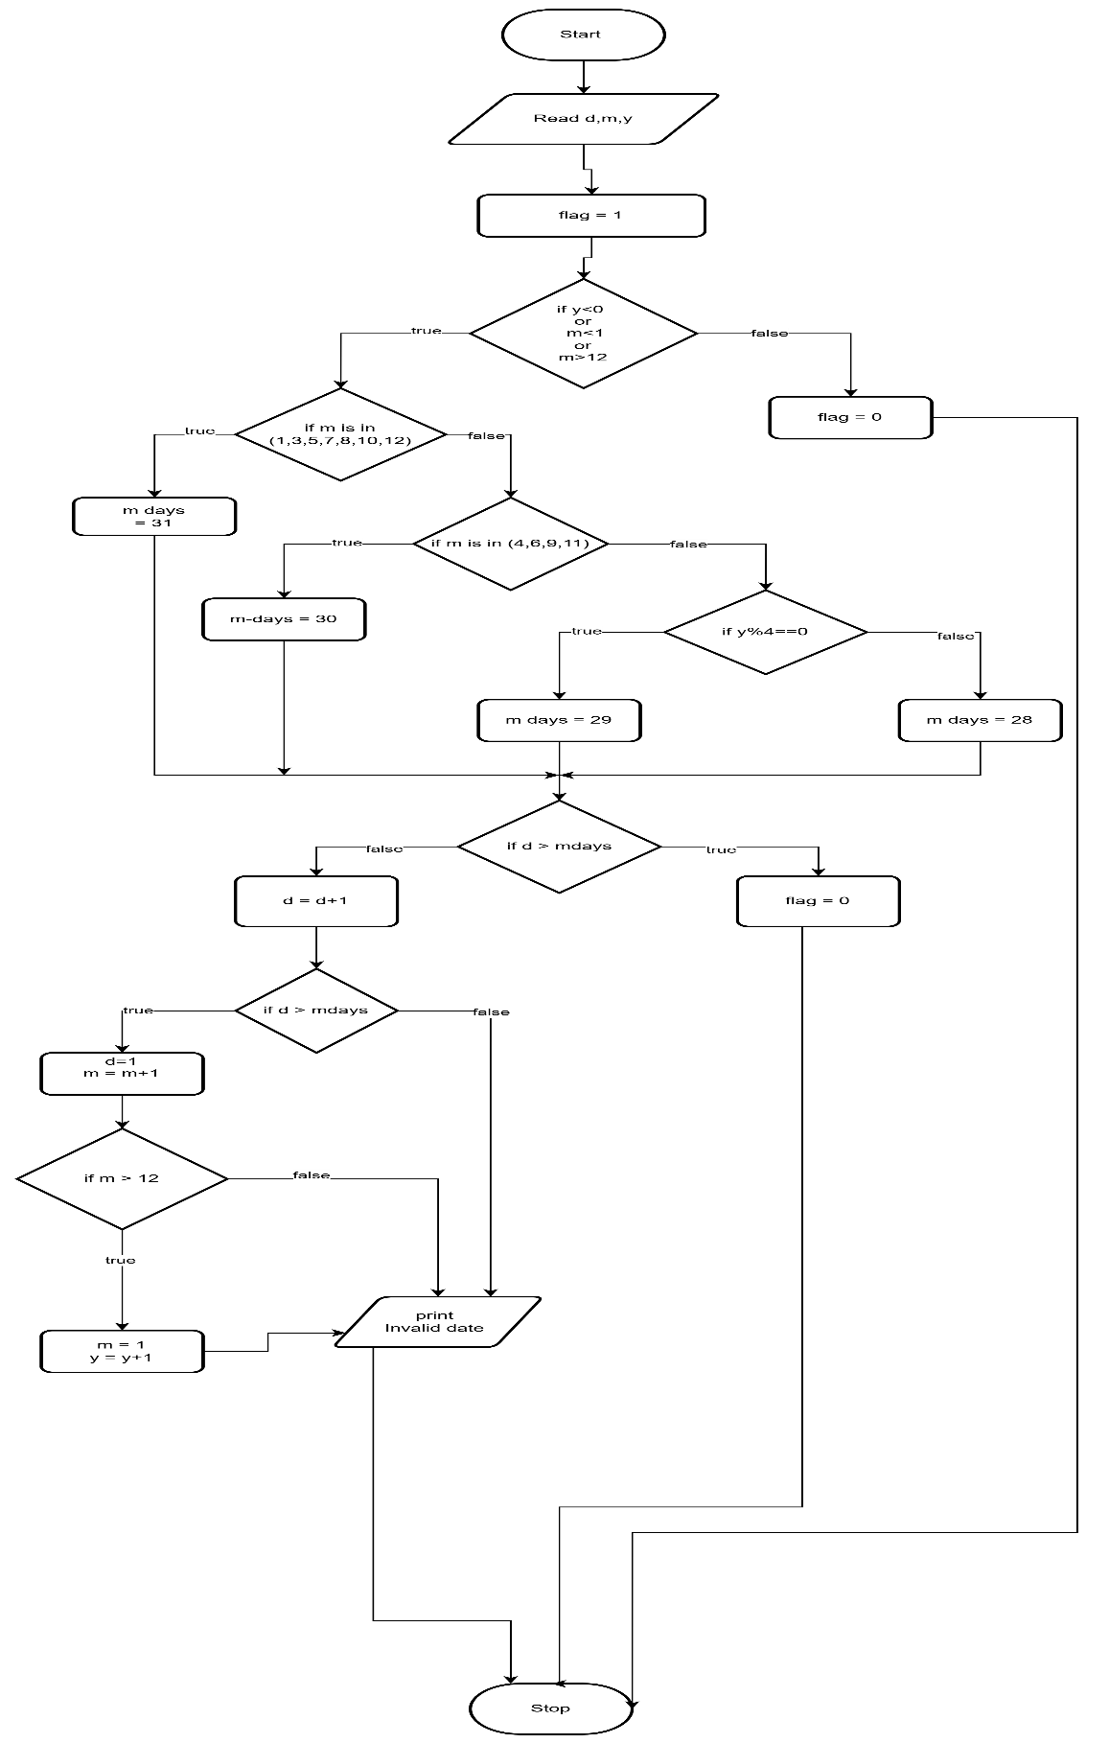

CODETANTRA:
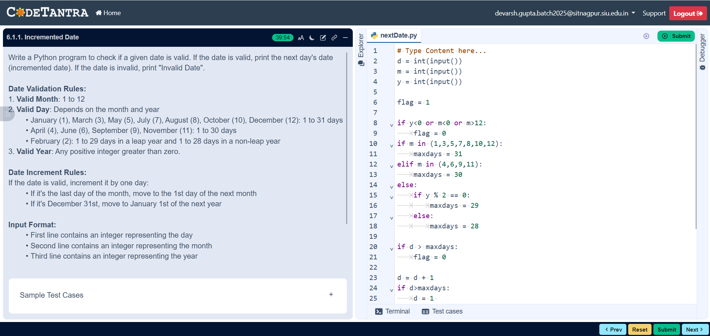

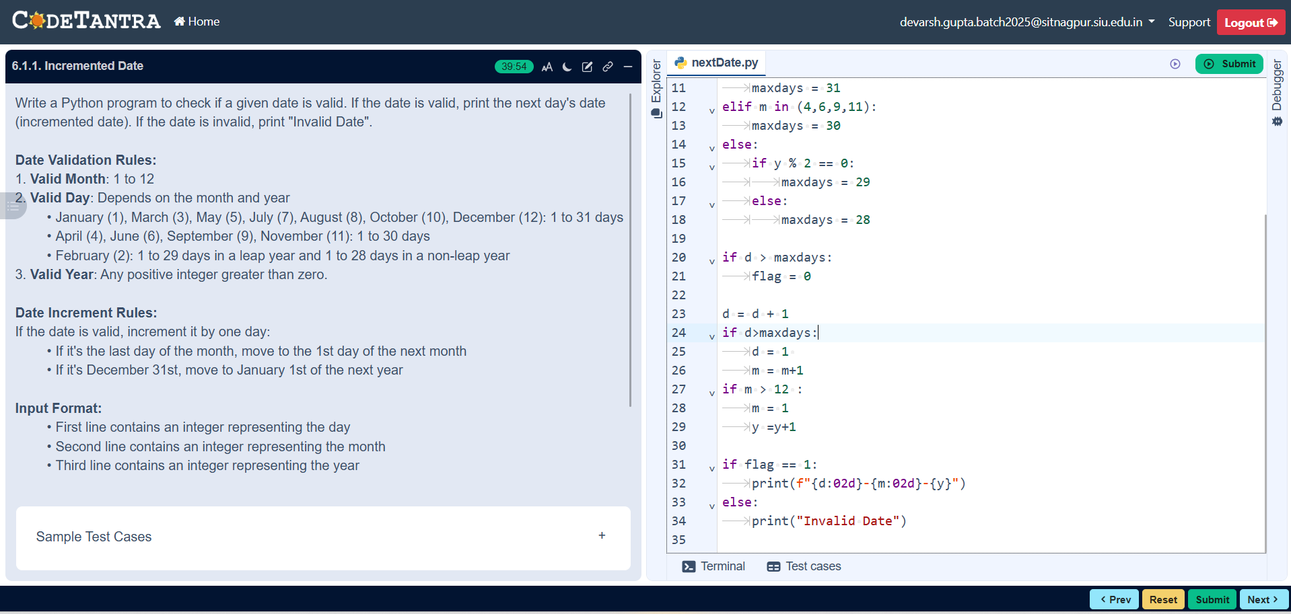
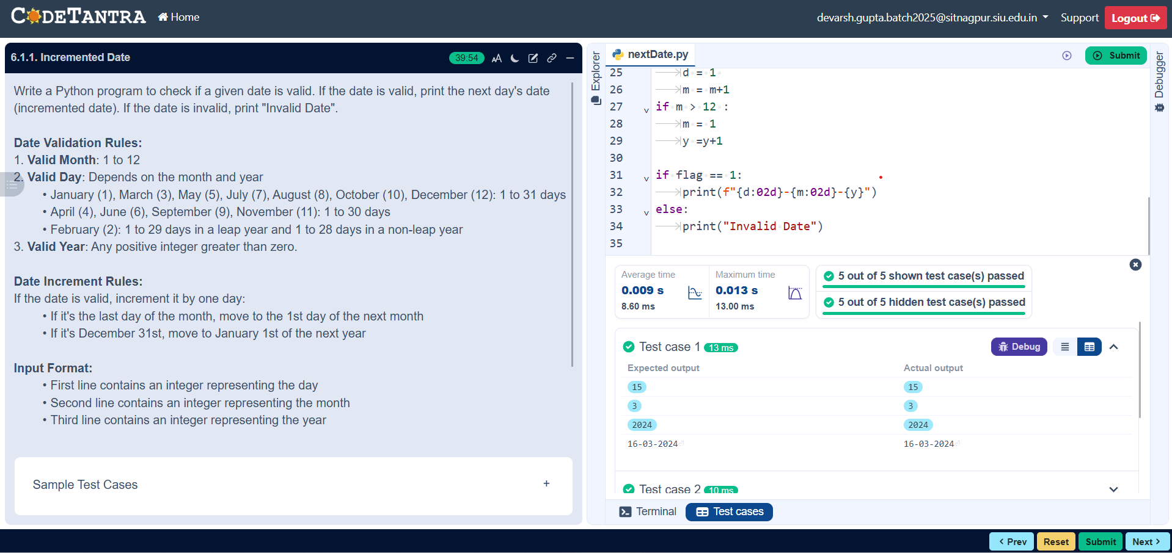

6.1.2//Factorial of a number
Ans: ALGORITHM:
- Start
- Input number n
- Set fact = 1
- Set loop variable i = 1
- Check if i ≤ N
  - If Yes → go to step 6
  - If No → go to step 8
- Compute fact = fact × i
- Increment i = i + 1 and go back to step 5
- Print fact
- Stop

FLOWCHART:
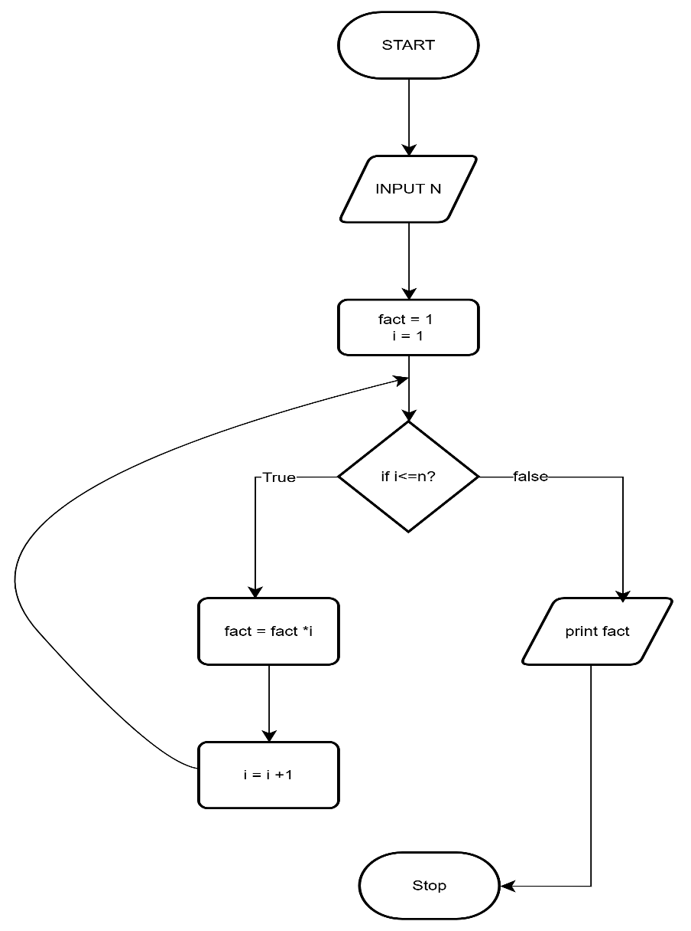

CODETANTRA:

